**SETTING UP APPLICATION ENVIRONMENT**

|  |  |
| --- | --- |
| Team ID | PNT2022TMID29529 |
| Project Name | Inventory Management System for Retailers |

|  |  |
| --- | --- |
| **TASK** |  |
| o | **Create Flask Project** |
| o | **Create IBM Cloud Account** |
| o | **Install IBM Cloud CLI** |
| o | **Docker CLI Installation** |
| o | **Create An Account In SendGrid** |

Create Flask Project

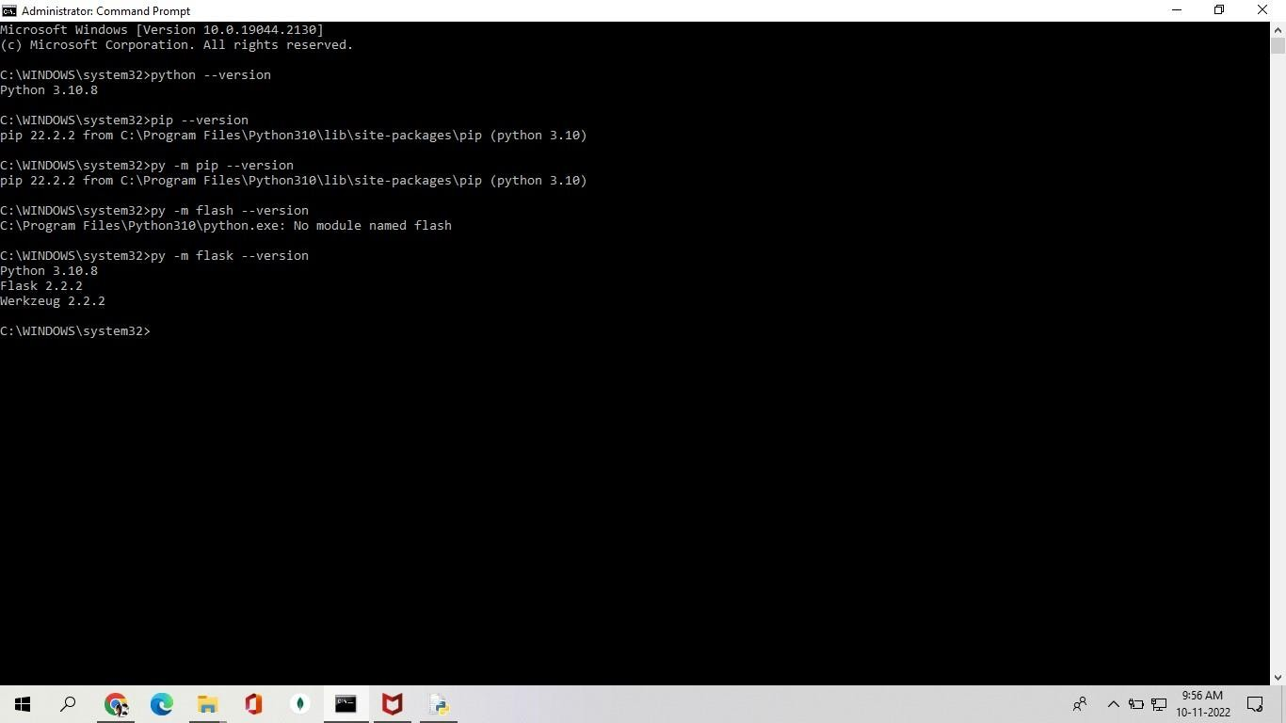

Create IBM Cloud Account

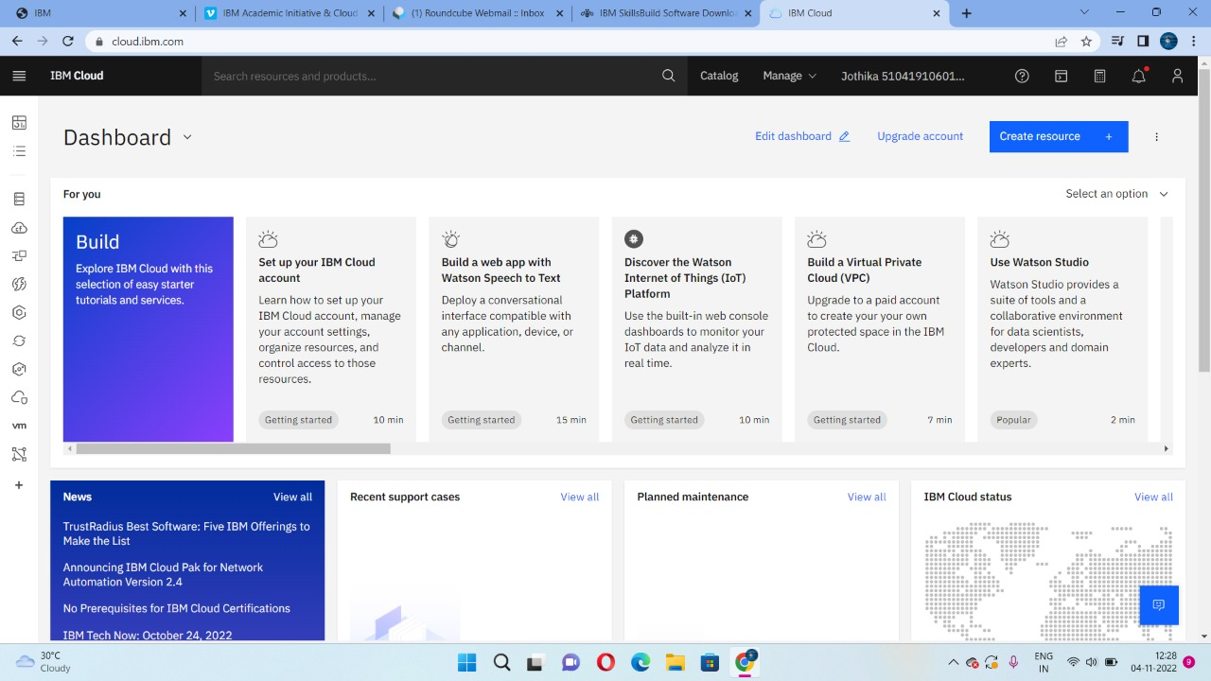

Install IBM Cloud CLI

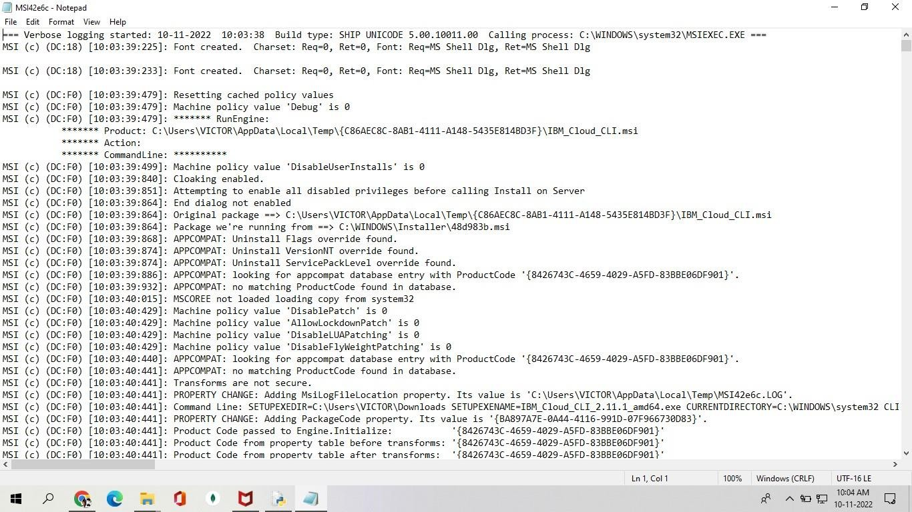

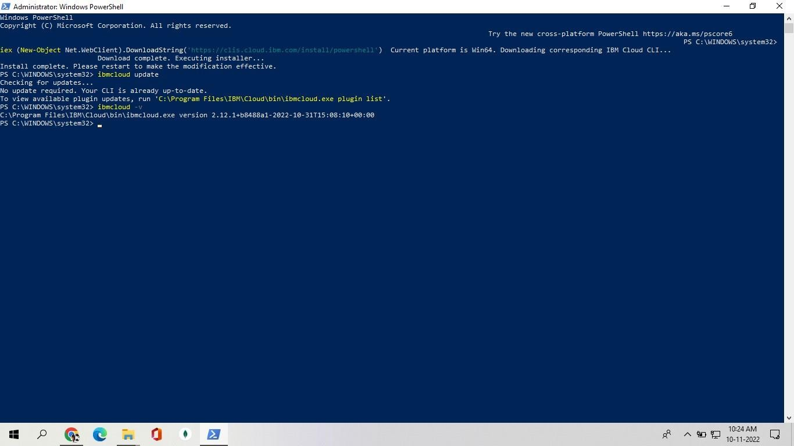

Docker CLI Installation

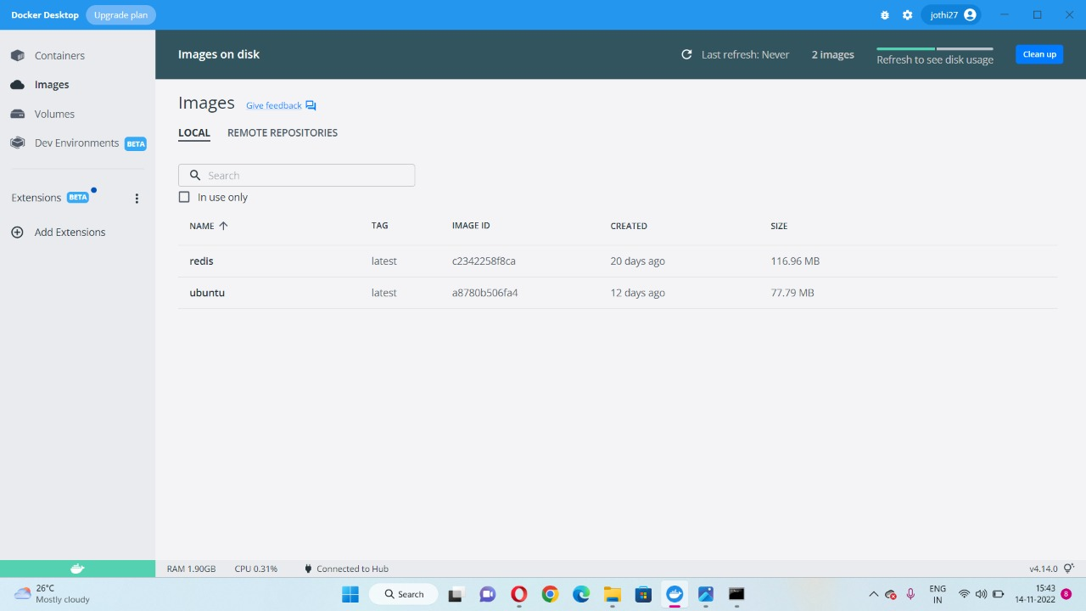

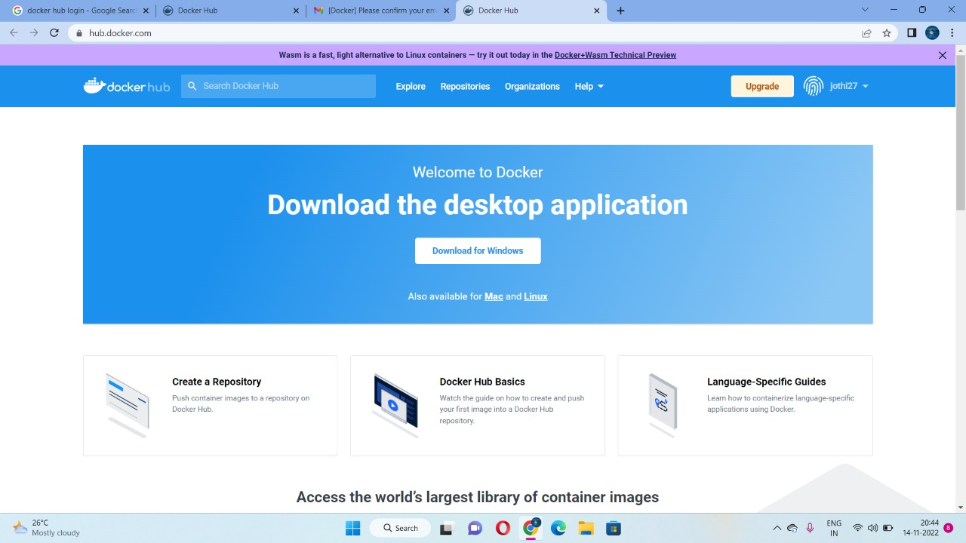

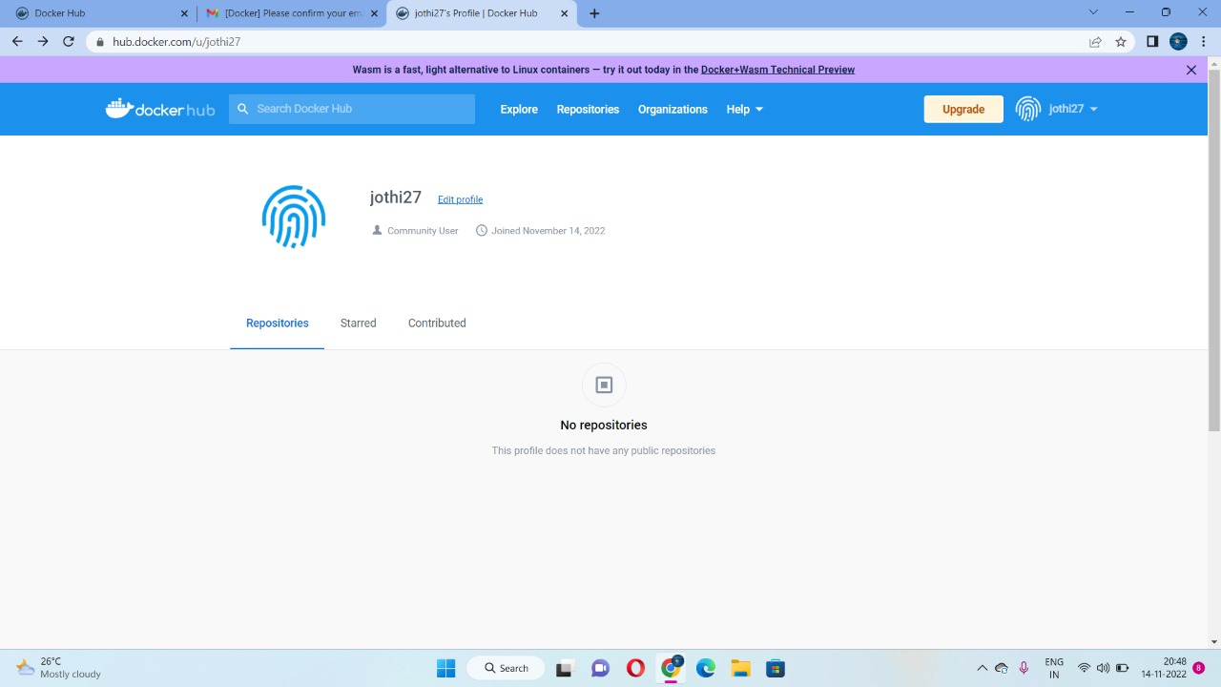

Create An Account In SendGrid

